Neural net Training – Forward and Back Propagation Algorithm and Numeric Example
Mark Rudolph
Abstract
Artificial neural networks (ANNs) are a powerful class of models motivated by biological neural computation and used for a wide array of classification and generative tasks. The idea behind ANNs is straightforward: map some input onto a desired target value using a cascade of linear matrix transformations between each pair of layers, followed by a nonlinear activation function of the each component the vector*matrix result which is written to the corresponding unit of the next layer. The output layer is a prediction of the target output, and an error function can be calculated. Then the partial derivative of the error function with respect to the rightmost set of weights is calculated, and contributes in a leftward direction via increasing chain-rule derivative products in order calculate gradients for each weight. These gradients are used to adjust the weights at eah stage right-to-left, i.e backwards. Backpropagation is an algorithm used to train neural networks, used along with an optimization routine such as gradient descent. Gradient descent requires access to the gradient of the error function with respect to all the weights in the network to perform a weight update, in order to minimize the error function. Backpropagation computes these gradients in a systematic way. Backpropagation along with Gradient descent is arguably the single most important algorithm for training Deep Neural Networks and could be said to be the driving force behind the recent emergence of Deep Learning. In this paper I give a step-by-step walk-through of the derivation of gradient descent learning algorithm commonly used to train ANNs (the backpropagation algorithm). Included is a simple general 3-layer ANN program in Python (requiring only Numpy for convenience), and a particular 2x2x2 ANN program example with full numerical assignments and step-by-step derivations.

Introduction
The backpropagation algorithm was originally introduced in the 1970s, but its importance wasn't fully appreciated until a famous 1986 paper by David Rumelhart, Geoffrey Hinton, and Ronald Williams. That paper describes several neural networks where backpropagation works far faster than earlier approaches, making it possible to use neural nets to solve problems which had previously been insoluble. Today, the backpropagation algorithm is the workhorse of learning in neural networks.
A neural network first forward propagates the input data via matrix multiplications of the data vector at each layer through a weights matrix, and then writing a non-linear activation of the result to the corresponding unit of the next layer, and so on – this is termed ‘forward propagation’. The output layer units are the current prediction of the actual ‘target’ output and an error function is calculated for each unit. The gradient partial derivative of this error is calculated for each weight for each succeeding layer in the backwards direction – this is termed ‘back propagation’. The process is one iteration in the training algorithm and happens step by step:
- The network makes an output prediction about, using its present parameters
- The prediction error is measured with a loss function
- The gradient of the error with respect to each weight, which is the direction of steepest slope in the space of weights, is backpropagated to adjust the weights in order to reduce the error in the output prediction in the next forward propagation. Each weight is incremented by a factor proportional to the negative of the gradient. This ‘movement’ of each weight reduces the error prediction in the next forward pass, and overall the direction of adjustment converges to a (local) minimum of the error with respect to the weight, where the gradient is zero.

Numeric Example of a 2x2x2 three-layer network

Here’s the basic structure of the 2x2x2 three layer neural network:
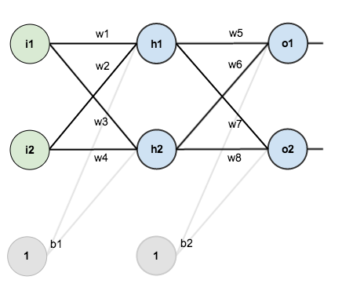

For added clarity I have modified some of the names of the variables in the diagram and follow those names in the following text and example programs in appendices 1 and 2. Appendix 1 is a Python 2x2x2 neural net (as pictured above) training program with variable names and numeric values described in the text below. Appendix 2 is a general IxJxK neural net training program, also closely following the variable names below, except using array indices instead of explicit indices 1 and 2 as above.
For simplicity the input layer units i1 and i2 are the same in every training iteration, as are the bias terms bi (the input bias term called b1 above) and bh (the hidden bias term called b2 above). The hidden layer units are h1 and h2, and the ‘prediction’ output layer units are o1 and o2.
The ‘target’ or goal outputs are target1 and target2 and the corresponding errors are E1 = .5*(target1 – o1)**2 and E2 = .5*(target2 – o2)**2. The total error is E is the sum of these squared errors, so E = E1 + E2.
The key elements in the example are the two weight matrices, renamed explicitly as follows:
{wihij} i and j in {1,2} are the weights between the input and hidden layers.
{whojk} j and k in {1,2} are the weights between the hidden and output layers,

wih11 is w1 in the diagram above. The ’ih’ in the variable name indicates that the weight is between the input and hidden layers, and specifically the weight applied to i1 whose product then contributes to h1.
Similarly, wih12 = w3, wih21 = w2 and wih22 = w4.
Note that h1 = wih11*i1 + wih21 * i2
Similarly, h2 = wih12*i1 + wih22 * i2

who11 is w5 in the diagram above. The ’ho’ in the variable name indicates that the weight is between the hidden and output layers, and specifically the weight applied to h1 whose product then contributes to o1.
Similarly, who12 = w7, who21 = w6 and who22 = w8.
Note that o1 = who11*h1 + who21 * h2
Similarly, o2 = who12*i1 + who22 * i2

Recall that the goal of the training and hence back propagation algorithm, is to adjust the sets of weights {wihij} i,j in {1,2} and {whojk} j,k in {1,2} in each iteration so that the next forward propagation reduces the error function E, i.e. the outputs {o1, o2} approach the values {taget1, target2}.
The full set of variables, their values and descriptions, are given below. Note that variables not initialized are computed in forward propagation as described later.

input layer units
i1 = .05
i2 = .10
bi = .35 input bias term

weights input layer -> hidden layer
wih11 = .15 weight for i1->h1
wih12 = .25 weight for i1->h2
wih21 = .2 weight for i2->h1
wih22 = .3 weight for i2->h2

hidden layer units - input*weight before activation function sigma
ih1 i1*wih11 + 12*wih21
ih2 i1*wih12 + 12*wih22
bh = .6 hidden layer bias term

hidden layer units - post activation function sigma
h1 sigma(ih1)
h2 sigma(ih2)
bh hidden layer bias term

weights hidden -> output
who11 = .4 weight for h1->o1
who12 = .5 weight for h1->o2
who21 = .45 weight for h2->o1
who22 = .55 weight for h2->o2

output layer units - hidden*weight before activation function sigma
ho1 h1*who11 + h2*who21
ho2 h1*who12 + h2*who22
output layer units - post activation function sigma
o1 sigma(ho1)
o2 sigma(ho2)

target 'goal' output values for o1, o2
target1 = .01
target2 = .99

Error terms - E is the total error (also referred to as total 'cost')
E1 .5*(target1 - o1)**2
E2 .5*(target2 - o1)**2
E E1 + E2

The non-linear activation sigmoid function
sigma(x) = 1.0/(1.0 + exp(-x)) (blue)
The derivative of the sigmoid function is
dsigma(s) = s * (1.0 - s) (red) for all points s = sigma(x) on sigma curve (blue

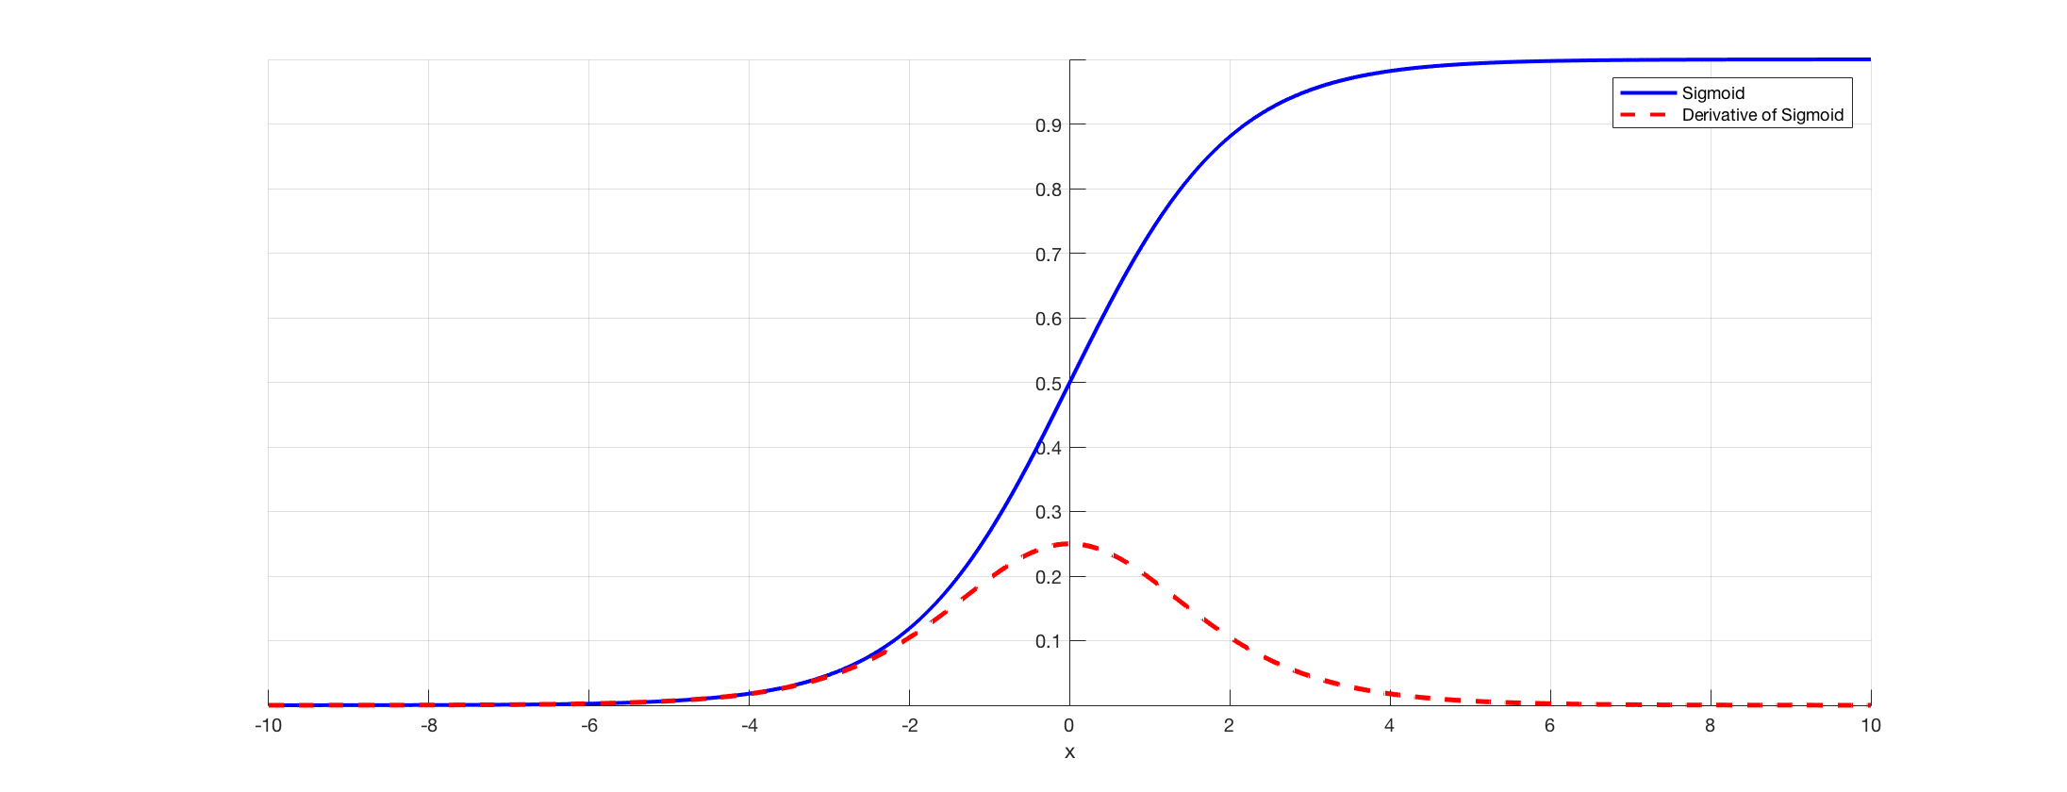

Step-by-Step Training Iteration – backprop222.py
It is useful to follow along with both the program sourcecode and the diagnostic output of the program (> py backprop222) captured in the file backprop222_diagnostics.txt. See the README.md for instructions on installing Python and the numpy module and the command line arguments and defaults.

[1] Forward Propagation from the input layer to the hidden layer:
Let's fully track the case of determining h1, the input wih-weighted sum ih1 of the inputs i1 and i2, with the sigma activation function applied.
Ih1 = i1 * wih11 + i2 * wih21 + 1 * bi = .05*.15 + 0.1*0.2 + 1*.35
= .3775
Then h1 = sigma(ih1) = sigma(.3775) = 1/(1 + exp(-.3775))
= .59327
Similarly h2 = .59688

[2] Forward Propagation from the hidden layer to the output layer:
Again let's track the case of determining the first output o1, the hidden layer units weighted by the who weights. The first result is ho1
ho1 = h1 * who11 + h2 * who21 + 1 * bh = .59327*.4 + .59688*.45+ 1*.6
= 1.106
Then o1 = sigma(ho1) = sigma(1.106) = 1/(1 + exp(-.1.106))
= .75136
Similarly h2 = .772928

